Data sources:

<https://www.kaggle.com/datasets/maitree/wine-quality-selection>

1. Clone Github

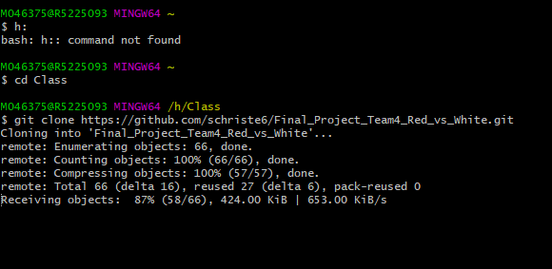

https://github.com/schriste6/Final_Project_Team4_Red_vs_White.git

1. Create branch: in github and gitbash--done
2. Gets CSVs and place in github: done
3. Make join plan
4. Rough ERD
5. Make ERD

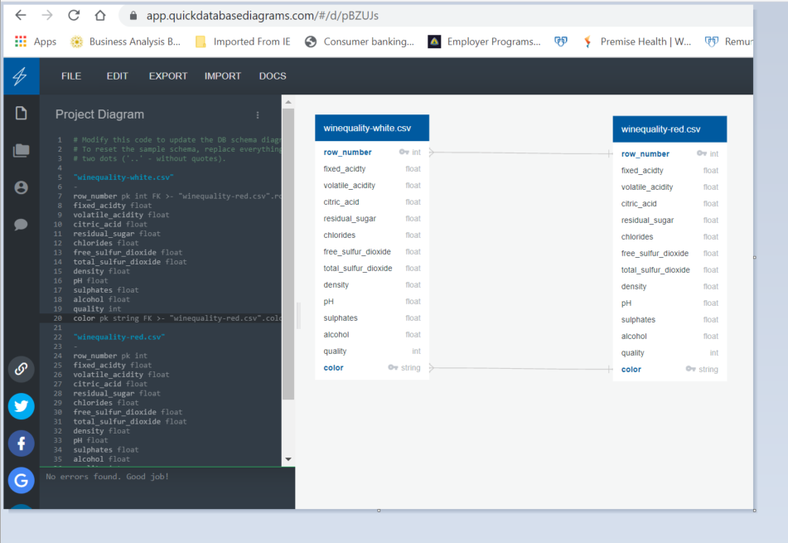

1. Use SQL to make new file
   1. Create DB
   2. Create tables
2. 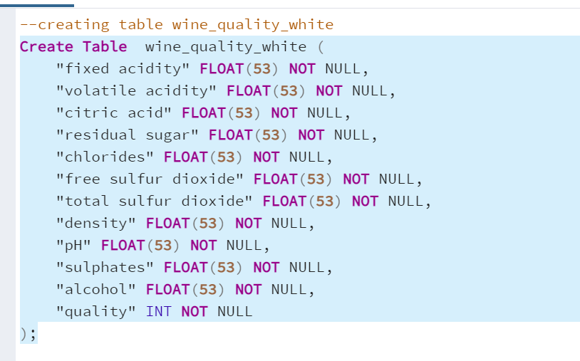

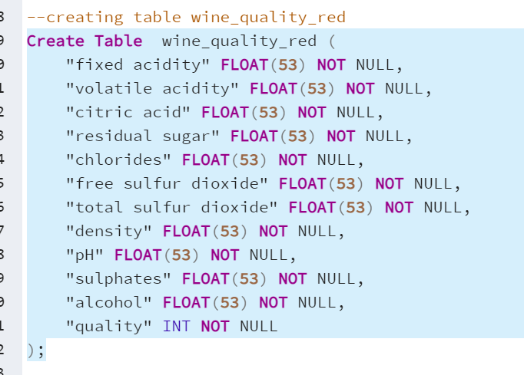

* 1. Import data

Done

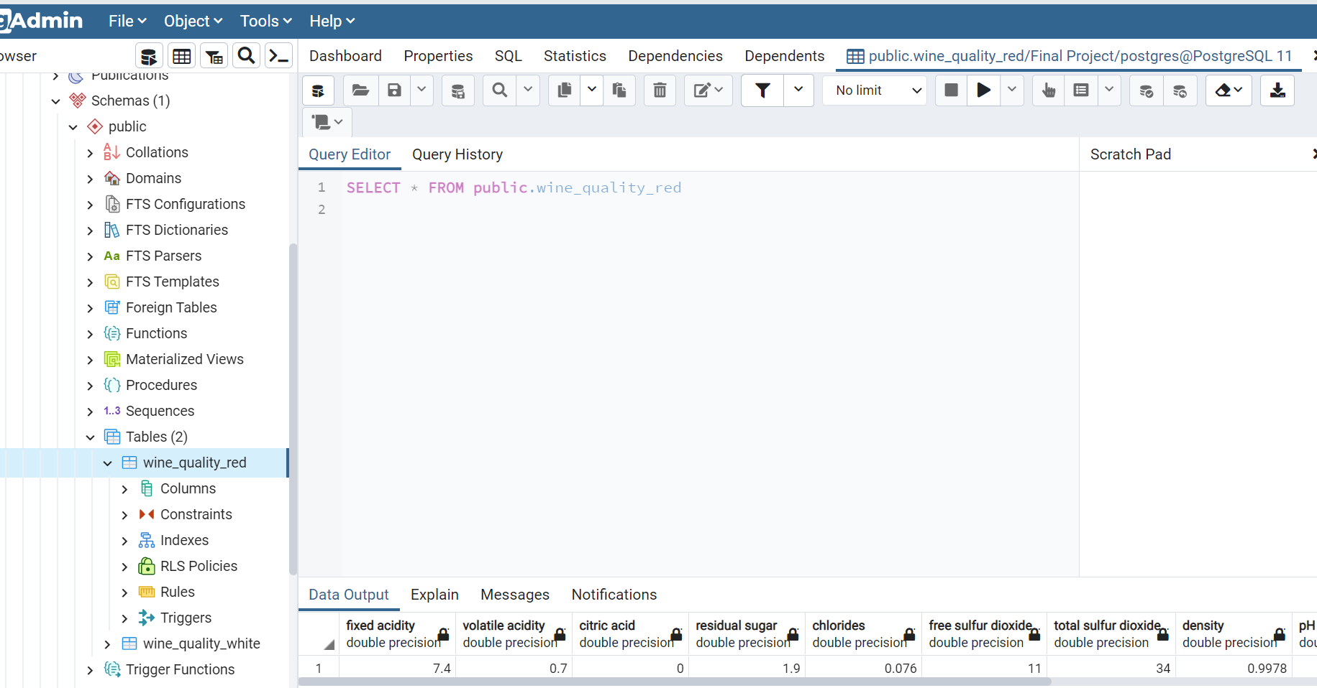

* 1. Troubleshoot
  2. Add Color columns:

1. 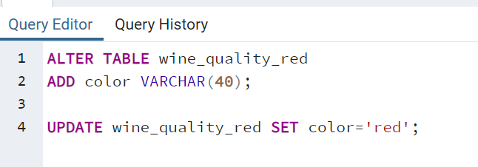
   1. Add row number columns:

Red:

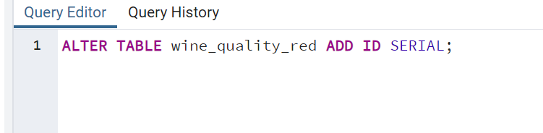

**White:**

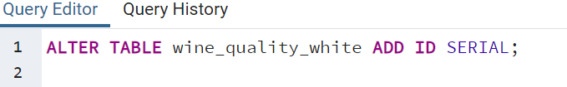

* 1. Remove blanks/clean data

1. Rename White columns as are duplicate from red:

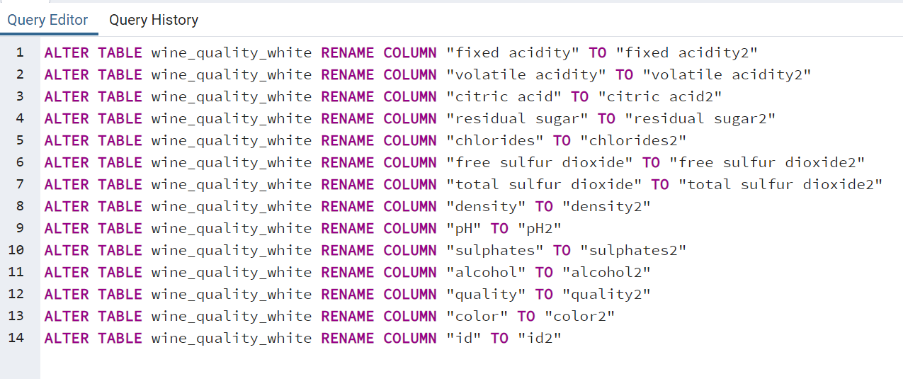

1. Join Tables

--joining wine_quality_white and wine_quality_red

SELECT wine_quality_red."fixed acidity",

wine_quality_red."volatile acidity",

wine_quality_red."citric acid",

wine_quality_red."residual sugar",

wine_quality_red."chlorides",

wine_quality_red."free sulfur dioxide",

wine_quality_red."total sulfur dioxide",

wine_quality_red."density",

wine_quality_red."pH",

wine_quality_red."sulphates",

wine_quality_red."alcohol",

wine_quality_red."quality",

wine_quality_red."color",

wine_quality_red."id",

wine_quality_white."fixed acidity2",

wine_quality_white."volatile acidity2",

wine_quality_white."citric acid2",

wine_quality_white."residual sugar2",

wine_quality_white."chlorides2",

wine_quality_white."free sulfur dioxide2",

wine_quality_white."total sulfur dioxide2",

wine_quality_white."density2",

wine_quality_white."pH2",

wine_quality_white."sulphates2",

wine_quality_white."alcohol2",

wine_quality_white."quality2",

wine_quality_white."color2",

wine_quality_white."id2",

INTO combined_wine_quality

FROM wine_quality_red.id

FULL OUTER JOIN wine_quality_white

ON wine_quality_red."fixed acidity" = wine_quality_white."fixed acidity2"

AND wine_quality_red."volatile acidity" = wine_quality_white."volatile acidity2"

AND wine_quality_red."citric acid" = wine_quality_white."citric acid2"

AND wine_quality_red."residual sugar" = wine_quality_white."residual sugar2"

AND wine_quality_red."chlorides" = wine_quality_white."chlorides2"

AND wine_quality_red."free sulfur dioxide" = wine_quality_white."free sulfur dioxide2"

AND wine_quality_red."total sulfur dioxide" = wine_quality_white."total sulfur dioxide2"

AND wine_quality_red."density" = wine_quality_white."density2"

AND wine_quality_red."pH" = wine_quality_white."pH2"

AND wine_quality_red."sulphates" = wine_quality_white."sulphates2"

AND wine_quality_red."alcohol" = wine_quality_white."alcohol2"

AND wine_quality_red."quality" = wine_quality_white."quality2"

AND wine_quality_red."color" = wine_quality_white."color2"

AND wine_quality_red."id" = wine_quality_white."id2"

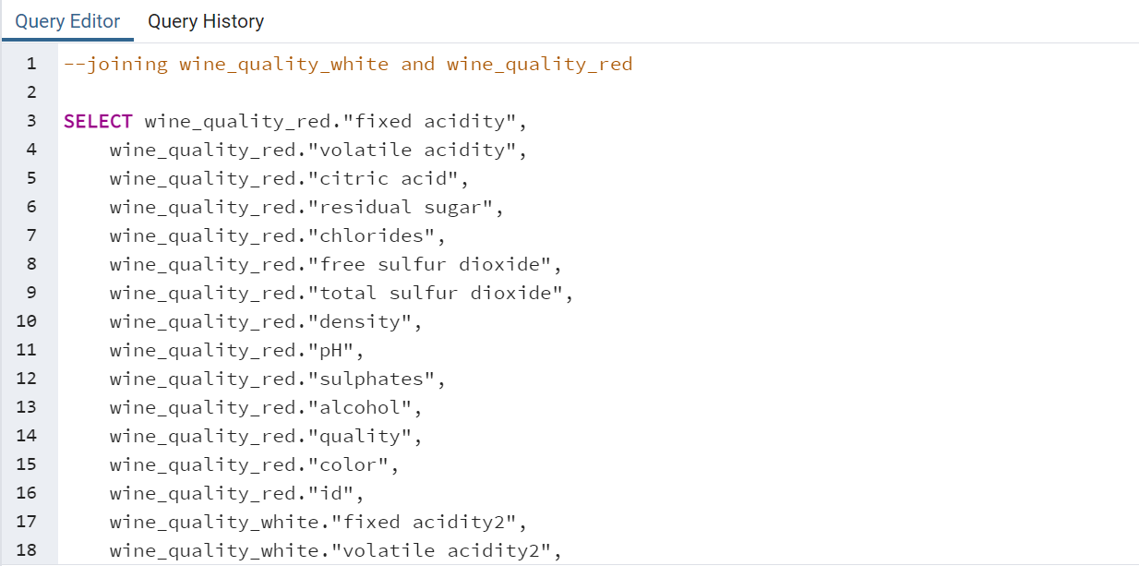

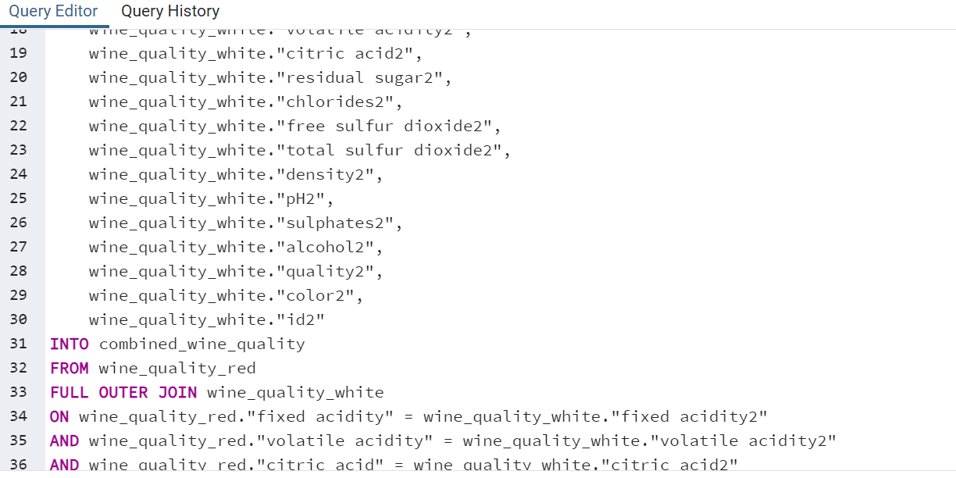

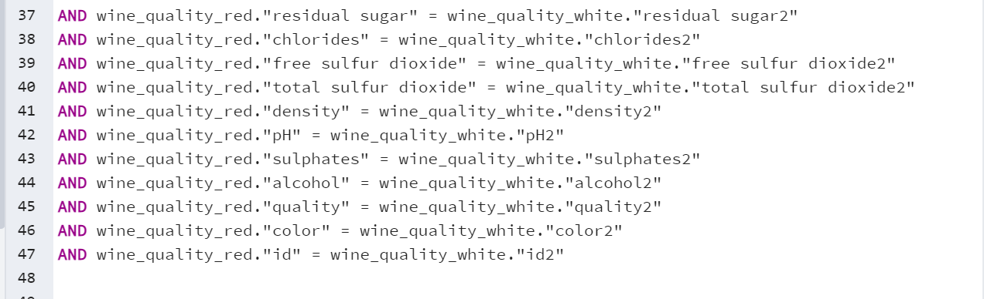

1. COMBINE COLUMNS AND Delete/drop unnecessary columns

Did the following for each of the columns

UPDATE combined_wine_quality

SET "fixed acidity" = "fixed acidity2"

WHERE "fixed acidity" IS NULL

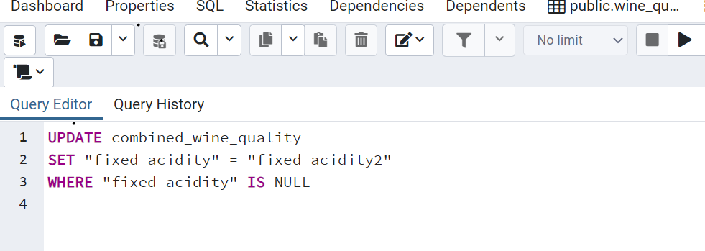

Then dropped each of the columns with a “2” appended:

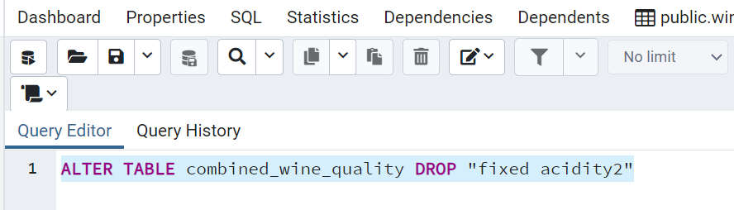

1. Load data into python or sQL alchemy, etc.
   1. Connect pandas and sql
2. Create branch
3. Upload to github Jessica branch
4. Upload to github—commit to main branch (4 commits)

